**HO CHI MINH CITY UNIVERSITY OF ECONOMICS AND FINANCE**

Font: SFU Futura – Size 18, Bold, Center

**MSc. Dang Thanh Aze**

**Vo Phuoc B**

**MSc. Nguyen Thi C**

Font: Calibri – Size 16, Bold, Center

**Management Studies**

Font: Calibri – Size 36, Bold, Center

Font: Calibri – Size 14, Bold, Center

**Internal use only**

**2025**

format Entire document

* **A4 paper size, Page Setup:**

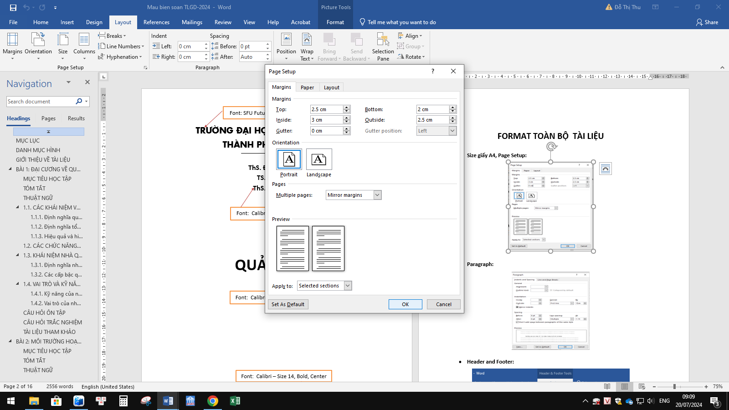

* **Paragraph:**

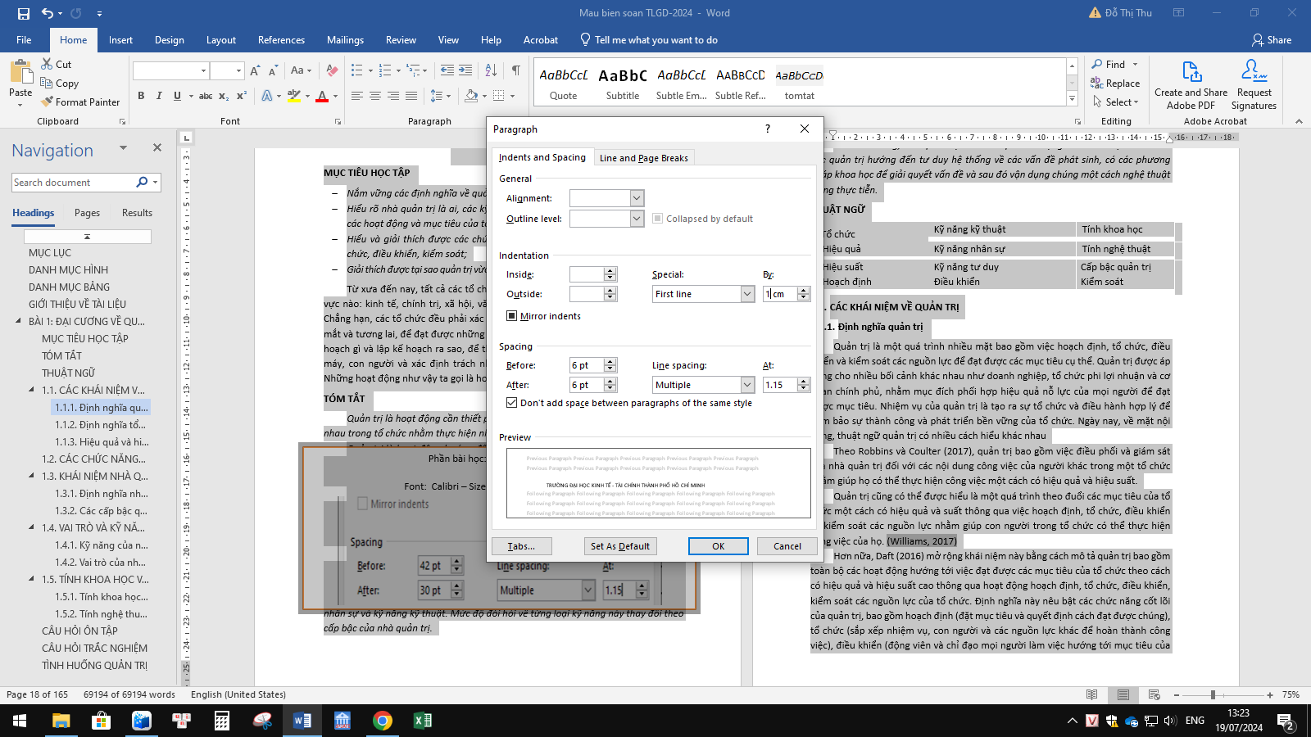

* **Header and Footer:**

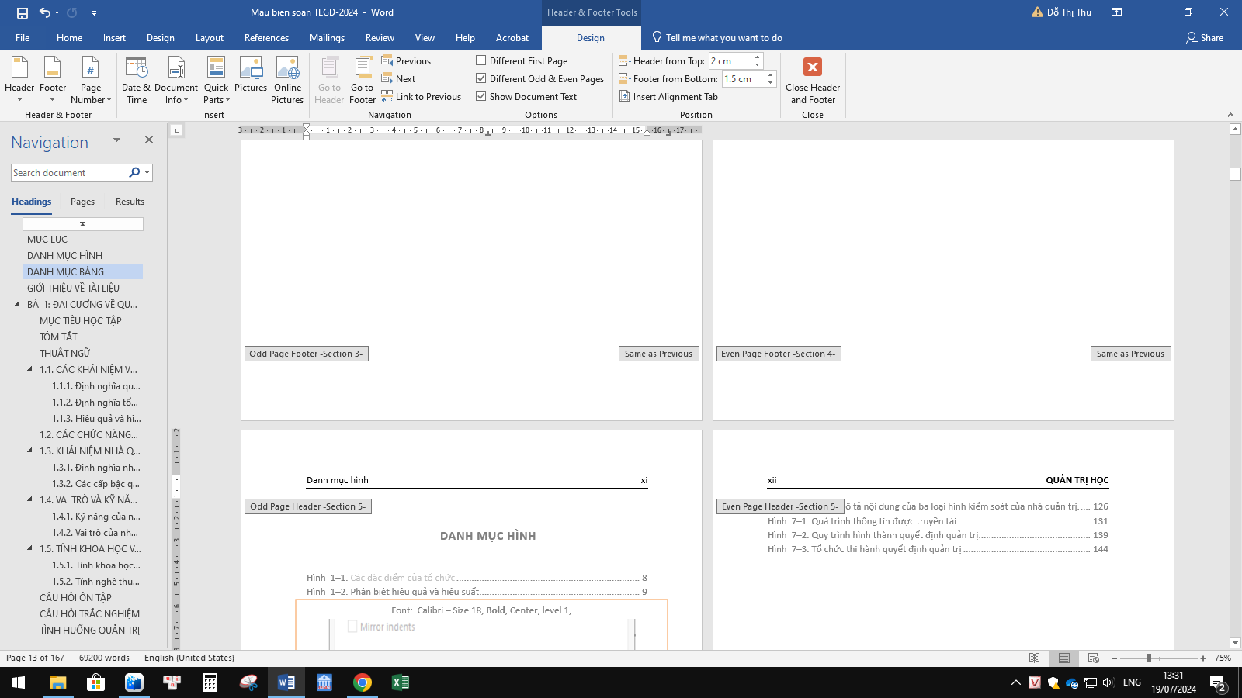

**Phần nội dung header and footer**

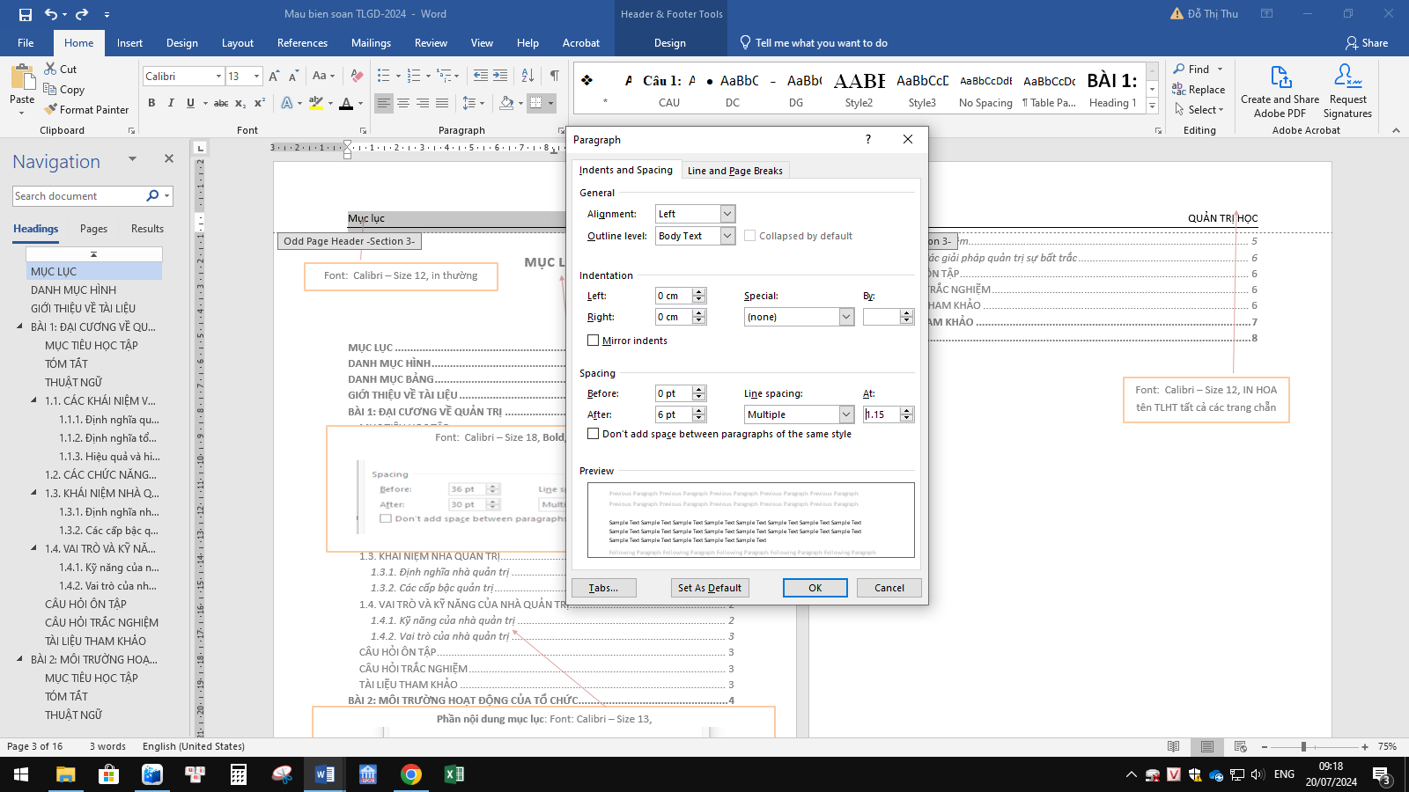

TABLE OF CONTENT

Font: Calibri – Size 12, in thường, trang bắt đầu đánh từ số la mã iii từ trang mục lục,

Font: Calibri – Size 12, in thường

TABLE OF CONTENTS  iii

LIST OF  FIGURES

INTRODUCTION TO THE DOCUMENT  vii

TOPIC 1: GENERAL INFORMATION ABOUT MANAGEMENT  1

LEARNING OBJECTIVE  1

SUMMARY  1

Font: Calibri – Size 18, **Bold**, Center, level 1,

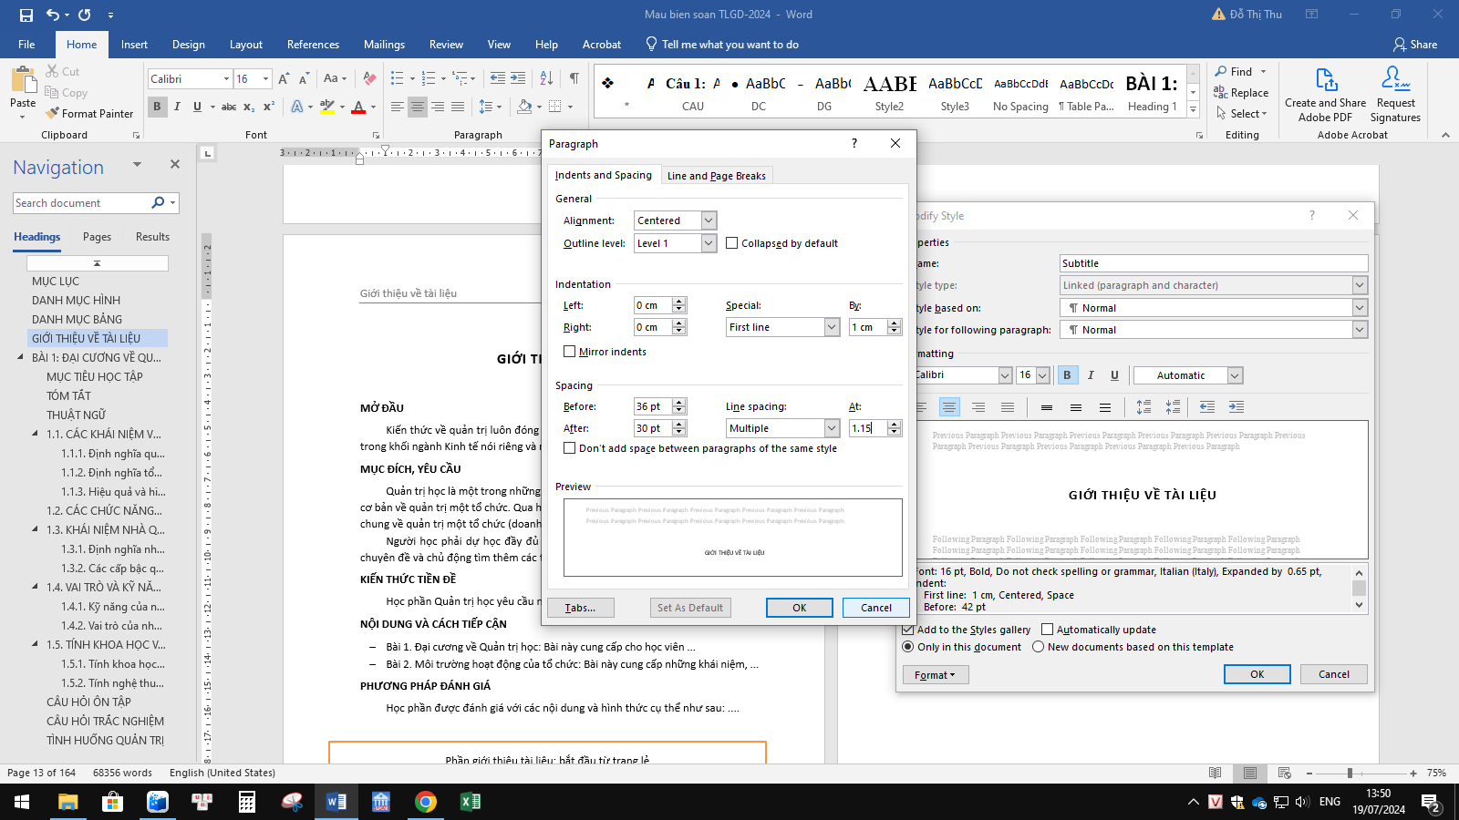

TERM  1

1.1. CONCEPTS OF MANAGEMENT  1

1.1.1. Definition of administration  1

1.1.2. Definition of organization  1

1.1.3. Efficiency and effectiveness in management  2

1.2. ADMINISTRATIVE FUNCTIONS  2

1.3. CONCEPT OF MANAGER  2

1.3.1. Definition of administrator  2

1.3.2. Management levels  2

1.4. ROLE AND SKILLS OF MANAGER  2

1.4.1. Skills of administrator  2

1.4.2. The role of the administrator  3

REVIEW QUESTION  3

MULTIPLE CHOICE QUESTION  3

REFERENCES  3

TOPIC 2: ORGANIZATION'S OPERATING ENVIRONMENT  5

LEARNING OBJECTIVE  5

**Phần nội dung mục lục**: Font: Calibri – Size 13, chỉ hiện mục lục đến level 3 (1.1.1, 1.1.2...)

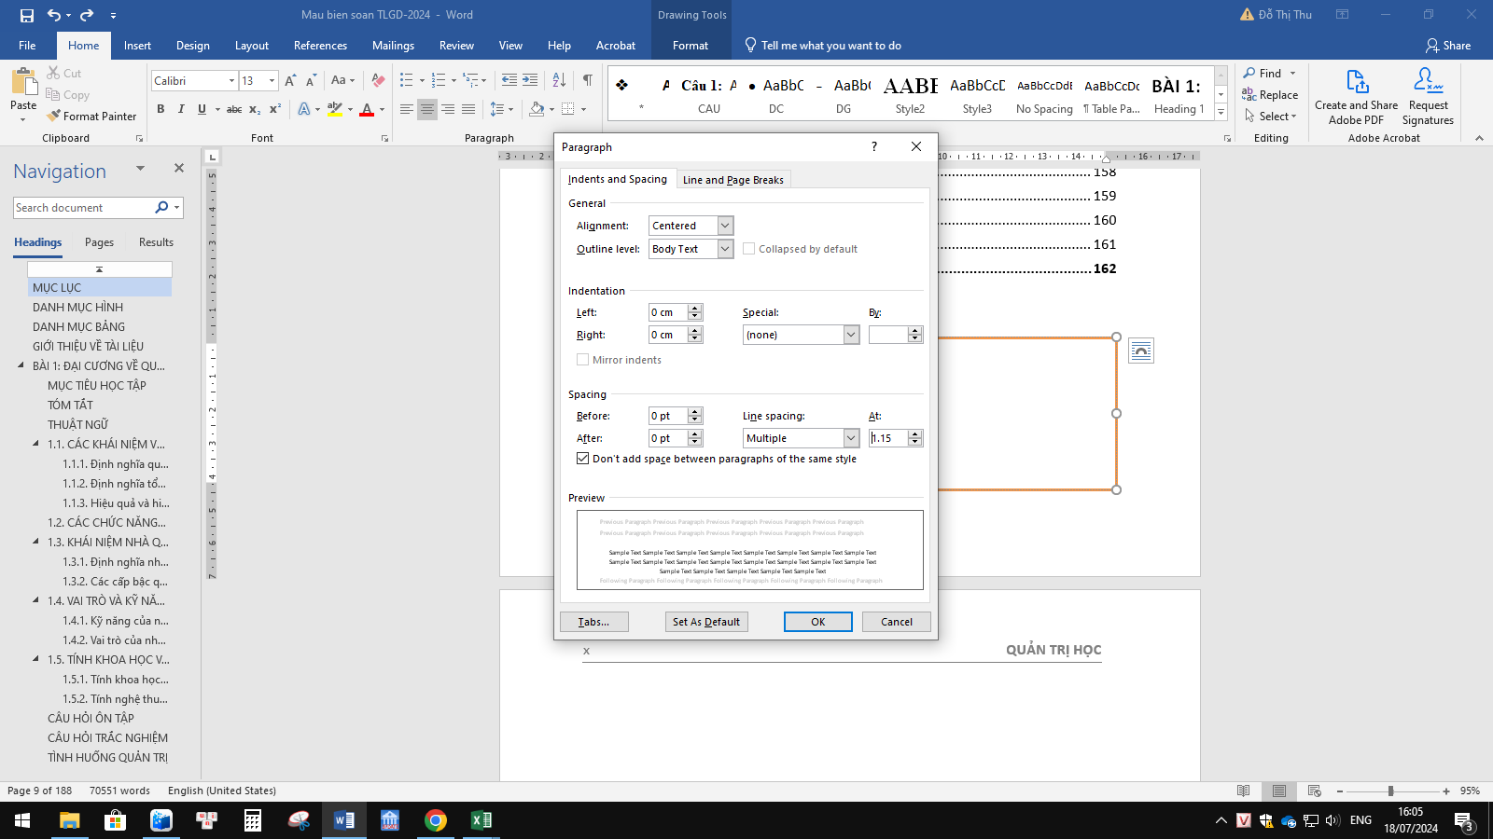

SUMMARY  5

TERM  5

2.1. CONCEPTS AND CLASSIFICATION OF ENVIRONMENT  5

2.1.1. External environment of the organization  5

2.1.2. Internal/internal environment  6

2.2. MANAGING UNCERTAINTY OF THE MANAGEMENT ENVIRONMENT  6

2.2.1. Concept  6

2.2.2. Uncertainty management solutions  7

REVIEW QUESTION  7

MULTIPLE CHOICE QUESTION  7

REFERENCES  7

REFERENCES  9

APPENDIX  11

Font: Calibri – Size 12, IN HOA tên TLHT tất cả các trang chẵn

LIST OF FIGURE

Figure 1–1 . Characteristics of organization  2

Figure 2–1. Michael Porter's Five Competitive Forces Model  6

**Phần nội dung Danh mục hình**: Font: Calibri – Size 13,



Font: Calibri – Size 18, **Bold**, Center, level 1, 

PREFACE

**INTRODUCTION**

Knowledge of management always plays an important role for all students in the field of Economics in particular and some related fields. Therefore, ...

**PURPOSE, REQUIREMENTS**

Management is one of the prerequisite courses that provides basic knowledge about managing an organization. Through this course, students will grasp the general theory of managing an organization (enterprise), including:...

Students must attend all classes, participate in thematic reports and actively seek additional information.

**PREREQUISITE KNOWLEDGE**

The course Management requires students to have ....

**CONTENT AND APPROACH**

* Topic 1. General Introduction to Management: This lesson provides students with ...
* Topic 2. Organizational environment: This lesson provides concepts, ...

**EVALUATION METHOD**

The course is assessed with specific content and form as follows: ....

**Tiêu đề: GIỚI THIỆU TÀI LIỆU**

Bắt đầu từ trang lẻ. Font: Calibri – Size 18, **Bold**, Center, level 1,



# 

# TOPIC 1: GENERAL INFORMATION ON MANAGEMENT

Font: Calibri – Size 12, in thường, trang bắt đầu đánh từ số 1

LEARNING OBJECTIVES

* *Grasp the definitions of management;*
* *Understand who a manager is, the skills and roles of a manager in all activities and goals of the organization ;... .*

SUMMARY

*Management is a necessary activity that must be performed when people come together in an organization to achieve common goals with high efficiency.*

**Phần tiêu đề BÀI 1: TÊN BÀI**

Các bài 1, 2, 3... bắt đầu từ trang lẻ

Font: Calibri – Size 18, **Bold**, Center, level 1,



*Management is a goal-oriented activity based on the use of resources. People play a very important role in management and management activities are often affected by environmental impacts.*

*An administrator is a person who holds a special position, is given the authority to control people and is responsible for the results of activities in the organization corresponding to his or her level. In an organization, administrators are often divided into 3 levels of management: high level, middle level, low level.*

*Managers must take on many different roles. Based on the general nature of .....*

TERMINOLOGY

|  |  |  |
| --- | --- | --- |
| *Organization* | *Technical skills*  **MỤC 1.1. TÊN MỤC IN HOA**  Font: Calibri – Size 13, in đậm (Bold)., level 2  (Đánh số 1.1, 1.2... các đề mục lớn theo bài) | *Scientific* |
| *Effective* | *Human skills* | *Artistic* |
| *Efficiency*  *Planning* | *Thinking skills*  *Control* | *Management level*  *Control* |

## CONCEPTS OF MANAGEMENT

### Definition of management

**Mục 1.1.1. Tên mục in thường**

Font: Calibri – Size 13, in đậm (Bold)., level 3

(Đánh số 1.1.1., 1.1.2.... các đề mục nhỏ theo bài, )

Management is a multifaceted process that involves planning, organizing, directing, and controlling resources to achieve specific goals. Management is applied to a variety of contexts such as businesses, non-profit organizations, and government agencies, with the aim of effectively coordinating the efforts of people to achieve....

### Definition of organization

An organization is a group of people working together to achieve specific goals. (Kinicki & Williams, 2019)An organization can be ...

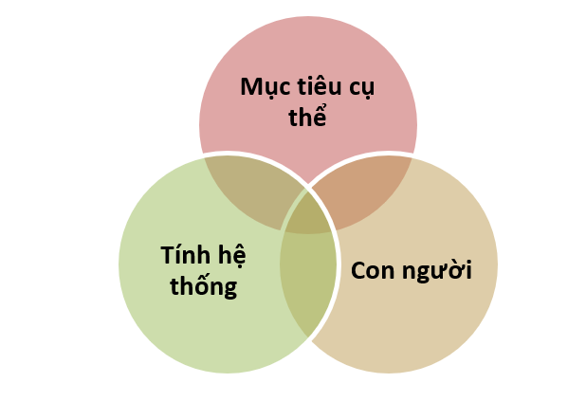

**Nguồn trích**: Font: Calibri – Size 13, *in nghiêng*, canh trái, để trong ngoặc đơn (*nguồn trích*)

***Phần hình, ảnh, bảng biểu, sơ đồ...***

Font: Calibri – Size 13, in nghiêng (Italic).

Nội dung: *Hình 1-1: Tên hình (1 là tên chương, -1 là số thứ tự hình của chương đó)*

Figure 1 – 1 . Organizational characteristics

*(Source: (Robbins & Coulter, 2017))*

### Efficiency and effectiveness in management

There are two concepts that need to be clearly distinguished when studying management concepts, which are the concepts of efficiency and effectiveness. A management activity is considered successful when it achieves both efficiency and effectiveness.

* ***Effectiveness* :**

Management effectiveness must first be understood as doing the right things. (Robbins & Coulter, 2017)Doing the right things means doing the work to help the organization achieve its goals, helping the organization ....

## ADMINISTRATIVE FUNCTIONS

Management functions are general, general groups of tasks that managers at all levels perform. More specifically, management functions ...

## CONCEPT OF MANAGER

### Definition of administrator

In an organization there must be people who do specific jobs and people who manage the people who do specific jobs...

### Levels of management

As mentioned above, administrators will be assigned to different positions and levels depending on their roles and responsibilities. Generally, in an organization, there will be 3 levels of administration…

## ROLE AND SKILLS OF MANAGER

### Managerial skills

Management skills are the abilities and competencies required to manage effectively at different levels in an organization. To complete different tasks, managers need different skills such as communication skills, analytical skills, decision making skills, ….

### The role of the administrator

Managers have many roles to take on in an organization. To take on them effectively, managers need to clearly understand each role they have to perform. Although not clearly stated in the job description, depending on the time...

REVIEW QUESTIONS

**TÊN MỤC IN HOA**

Font: Calibri – Size 13, in đậm (Bold)., level 2

(Lùi về đầu dòng)

1. Explain the concept of management.
2. Distinguish between efficiency and effectiveness. Give specific examples.
3. ....

MULTIPLE CHOICE QUESTIONS

1. What are the four basic functions of management?
   1. Planning, directing, controlling, and staffing
   2. Planning, organizing, commanding, coordinating
   3. Planning, organizing, directing, controlling
   4. Organize, arrange staff, direct, inspect, evaluate
2. People divide the levels of management in an organization into:
3. .....

REFERENCES

1. Chau, PT, Diep, NT, & Lan, PX (2014). *Management textbook.* Phuong Dong.
2. Daft, R.L. (2016). *New era of management* (11 ed.). Cengage Learning.
3. Drucker, P.F. (2020). *The essential drucker.* Routledge.
4. .........

# 

# TOPIC 2: ORGANIZATION'S OPERATING ENVIRONMENT

LEARNING OBJECTIVES

* *Understand the nature of an organization's operating environment;*
* *Explain environmental factors affecting the organization;*
* ....

SUMMARY

*The environment of an organization is the sum of factors from inside and outside the organization that have a direct influence on ...*

TERMINOLOGY

|  |  |  |
| --- | --- | --- |
| *Organizational environment* | *Macro environment* | *Uncertainty Management* |
| *Internal environment* | *Micro environment* | *Inbound Logistics* |
| *External environment* | *Organizational value chain* | *Output logistics* |

## CONCEPTS AND CLASSIFICATION OF ENVIRONMENT

According to Robbins and Coulter (2017), organizational environment refers to the sum of all external and internal factors that influence the operation, sustainability, and growth of an organization. ...

Below are some definitions and classifications of organizational environment.

### The organization's external environment

External factors in the organizational environment refer to the factors that can influence the organization's performance and strategy. ...

#### Macro environment

The macro environment represents the overarching external factors that impact the organization on a broad scale, transcending specific industries and markets ....

#### Micro environment or industry environment

***Mục 2.1.1.1***. ***Tên mục in nghiêng***

Font: Calibri – Size 13, in đậm (Bold)., level 3

(Đánh số ***1.1.1.1, 1.1.1.2***.... các đề mục theo bài, )

The micro environment refers to the external factors that directly affect the organization's business operations. Unlike the macro environment, which includes the following ...sections (see Figure 2.1):

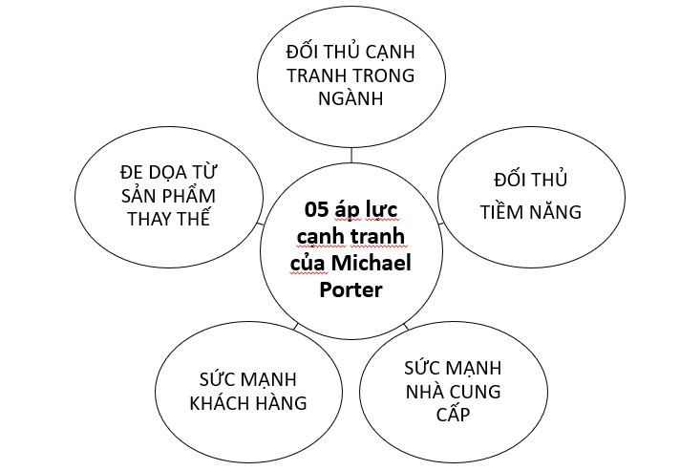

Figure 2 – 1. Michael Porter's 5 competitive capabilities model

*( Source: (Michael Porter, 1985))*

Customers are a part of the micro-environment, as their needs and preferences directly influence the marketing and sales strategies of the organization. On the other hand, suppliers influence the availability and cost of... .

### Internal environment

Internal environmental factors are subjective factors that affect the organization's production and business activities. It can be said that analyzing internal environmental factors is analyzing the points....

#### Main activities

Includes activities directly related to the organization's products or services including input activities, operations, activities... .

#### Support activities

In addition to the main activities directly related to products and services, the organization's value chain also includes activities that affect ...

## MANAGING UNCERTAINTY OF THE MANAGEMENT ENVIRONMENT

### Concept

Managing environmental uncertainty is the process of identifying, assessing and responding to uncertain and changing factors in the business environment, in order to ensure the existence and sustainable development of the ...

### Uncertainty Management Solutions

Managing the uncertainty of the management environment requires activities such as information gathering, risk assessment, strategy formulation, networking, investment in research and development, competition creation, etc.

REVIEW QUESTIONS

1. What is the environment of an organization. Classification of the environment of an organization.
2. Why is environmental analysis important to managers?
3. ...

MULTIPLE CHOICE QUESTIONS

1. Which of the following factors is not mentioned as part of the economic factors in the macro environment affecting the organization?
2. Economic growth rate
3. Inflationary
4. Political stability
5. Exchange rate
6. How can technological innovation affect an organization's business operations? ....

REFERENCES

1. Chau, PT, Diep, NT, & Lan, PX (2014). *Management textbook* . Phuong Dong **.**
2. Fisher, R., Ury, W., & Patton, B. (1991). Getting to yes: Negotiating. agreement without giving in (2nd ed.). Penguin Books.
3. ....

REFERENCES

**TÀI LIỆU THAM KHẢO**:

Bắt đầu từ trang lẻ. Font: Calibri – Size 18, **Bold**, Center, level 1,



* **Book:**

Author(s). (Date of publication). *Title of book* . Place of publication: Publisher. Source URL/DOI (Digital Document Identifier). (If available)

* Authors of information cited in the article are defined as individuals (one author), groups (multiple authors), agencies, organizations (government, non-governmental, United Nations, scientific associations/groups, domestic and foreign). Do not include the author's academic title, degree, or social status.
* For authors who are Vietnamese or Asian (Chinese, Japanese, Korean, etc.): describe in chronological order.
* A name without a surname is usually a nickname or a descriptive pen name as recorded in the document. For example: Tan Da → Tan Da, Xuan Dieu → Xuan Dieu.
* Names have the structure of Surname - Middle name - Given name, describe the order and initialize the first letter of Surname - Middle name - Given name. For example: Nguyen Minh Chau → Nguyen, Minh Chau
* For individual authors who are foreigners with the structure Name - Night Surname, describe the island. Then the author's Last Name is moved before the middle name and the first name is written after, with the last name and first name separated by a comma (,). For example: Maxim Gorki → Gorki, Maxim, DJ Johnson → Johnson, DJ

**For example:**

1. Nguyen, Nhat Anh. (2019). *Blue Eyes* . Vietnam: Tre Publishing House.
2. Bond, B. (2002). *The Unquiet Western Front: Britain's Role in Literature and History* . Cambridge University Press: Cambridge.
3. Wallwork, A., & Southern, A. (2020). *100 tops to avoid mistakes in academic writing and presenting* . Springer International Publishing. <https://doi.org/10.1007/978-3-030-44214-9>

* **Journals, articles:**

Author(s). (Publication date). *Title of article* . Title of journal, volume number (issue number). Page number. Source URL/DOI (Digital Document Identifier) (If available) : yy.yyyyyyyyy.

**For example:**

1. Nguyen , Thuy Chinh, Hoang, Thai (2023). *Review: emulsion techniques for producing polymer based drug delivery systems* . Vietnam Journal of Science and Technology, vol. 61, no. 1.pp. 1–26. <https://doi.org/10.15625/2525-2518/17666>.
2. Jones, K.R. (2010). *The impact of climate change on biodiversity* . Science, 328(5981), 1239-1240.

* **Thesis, dissertation:**

Author(s). (Publication date). *Title* (Type of thesis, Training institution, Location). Source URL/DOI (Digital document identifier) (If available)

**For example:**

1. Ngo, Thanh Hung. (2021). *Evaluation of the results of aortic valve reconstruction surgery using the Ozaki method to treat simple aortic valve disease at E Hospital* (Doctoral thesis, Hanoi Medical University, Vietnam).

* **Documents on Website** :

Author(s). (Published date). *Title of article accessed* . http://…. (Website URL). If the author name cannot be found, replace it with the website name.

**For example:**

1. World Bank. (2018). *Logistics Performance Index* 2018. <http://www.worldbank.lpi.com/>
2. World Health Organization. (2021). *COVID-19 dashboard* . <https://covid19.who.int/>
3. Nguyen, Huu Cuong. (2021). *What is a scientific journal* . <https://tapchigiaoduc.edu.vn/article/86791/225/the-nao-la-mot-tap-chi-khoa-hoc/>

APPENDIX

**PHỤ LỤC**

Font: Calibri – Size 18, **Bold**, Center, level 1,

